**Experiment 4**

American International University- Bangladesh (AIUB)

**Department of Electrical and Electronic Engineering**

# EEE3102: Digital Logic and Circuits Laboratory

**Title:** Designing Multiplexer (MUX) and De-multiplexer (DEMUX), Priority Encoder and Decoder Circuits

# Introduction:

In this experiment, students will learn how to design and implement multiplexers (MUX) and demultiplexers (De-MUX) of different sizes using basic logic gates. They will also learn how to construct bigger multiplexer using smaller multiplexers. Students will also construct encoder and decoder circuits. Encoder and decoder circuits are very useful in information transmission, conversion, compression and maintaining the secrecy of any information.

# Theory and Methodology:

**Part I: Multiplexer and De-multiplexer**

A multiplexer (or mux) is a device that selects one of several inputs and forwards the selected input into a single line. A multiplexer of 2*n* inputs has *n* selection lines, which are used to select which input has to be sent to the output. A multiplexer is also called a data selector.

A de-multiplexer (or de-mux) is a device taking a single input and selecting one of many data-output- lines, which is connected to the single input.

**Multiplexer:**

In computer system, it is often necessary to choose data from exactly one of a number of possible sources. Suppose that there are four sources of data, provided as input signals D0 ,D1, D2 and D3. The values of these signals change in time, perhaps at regular intervals. We want to design a circuit that produces an output that has the same value as either D0 or D1 or D2 or D3, dependent on the values of two selection pins S1 and S0. Here, the number of selection pin is two. Four combinations are possible using these two selection pins S1 and S0, such as (S1, S0) = (0,0), (0,1), (1,0), (1,1). Each combination is dedicated for each input. Let us consider the output variable is f. Now if S1 = 0 and S0 = 0 then f = D0, if S1 = 0 and S0 = 1 then f = D1, if S1 = 1 and S0 = 0 then f = D2 and if S1 = 1 and S0 = 1 then f = D3.

It is important to know that there is a relationship between the number of input and the number of selection pins. If the number of selection pin of a MUX is n, then maximum 2n inputs are possible for that MUX. And the MUX will be called as 2n to 1 line MUX. The MUX we are going to design is a 4-to-1 MUX. There could be also 2to1 MUX, 8to1 MUX, 16to1 MUX etc.

For our design, there are 4 inputs and 2 selection pins. So, we have 6 inputs. Now if we draw the truth table for 6 different inputs, there will be 64 (26) input combinations. But, fortunately we can do it in a more convenient way as given below.

# Table: 1

|  |  |  |
| --- | --- | --- |
| S1 | S0 | f |
| 0 | 0 | D0 |
| 0 | 1 | D1 |
| 1 | 0 | D2 |
| 1 | 1 | D3 |

From the above truth table, we can write the function as given below.

𝑓 = 𝑆̅1𝑆̅0𝐷0 + 𝑆̅1𝑆0𝐷1 + 𝑆1𝑆̅0𝐷2 + 𝑆1𝑆0𝐷3 (1)

The logic circuit of the equation (1) is given in figure 1.

S1 S0

D0



f

D1

D2

D3

# Fig. 1: 4-to-1 Multiplexer De-multiplexer:

A De-multiplexer or De-mux is opposite to the multiplexer. It has only one input and several outputs and one or more selection pins. Depending on the combination of selection input, the data input will be routed to one of many outputs. Other inputs will be low. Depending on the number of output, demultiplexers are termed as 1to2, 1to4 and 1to8 demultiplexers etc. If the number of selection pin is n, then maximum 2n outputs can be accommodated.

We are going to design a 1to4 line de-mux having an input Din, two selection pins S1 and S0 and four outputs D0 ,D1, D2 and D3. Now if S1 = 0 and S0 = 0 then D0 = Din, if S1 = 0 and S0

= 1 then D1 =Din, if S1 = 1 and S0 = 0 then D2 = Din and if S1 = 1 and S0 = 1 then D3 = Din. We can draw the truth table as given below.

# Table: 2

|  |  |  |  |  |  |
| --- | --- | --- | --- | --- | --- |
| S1 | S0 | D0 | D1 | D2 | D3 |
| 0 | 0 | Din | 0 | 0 | 0 |
| 0 | 1 | 0 | Din | 0 | 0 |
| 1 | 0 | 0 | 0 | Din | 0 |
| 1 | 1 | 0 | 0 | 0 | Din |

From the above truth table we can write the functions for D0 ,D1, D2 and D3 as given below.

̅ … ( 3)

𝐷0 = 𝑆̅1𝑆̅0𝐷𝑖𝑛 (2)

𝐷1 = 𝑆̅1𝑆0𝐷𝑖𝑛 (3)

𝐷2 = 𝑆1𝑆̅0𝐷𝑖𝑛 (4)

𝐷3 = 𝑆1𝑆0𝐷𝑖𝑛 (5)

The circuit for 1-to-4 line de-mux is given below.

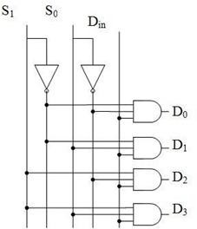

**Fig. 2:** 1-to-4 line De-multiplexer

It is also possible to construct 4-to-1 multiplexer (and 1-to-4 de-multiplexer) using 2-to-1 multiplexers (1- to-2 demultiplexers) only. Figures 3 and 4 show the construction of 4-to-1 multiplexer using 2-to-1 multiplexers and 1-to-4 de-multiplexer using 1-to-2 de-multiplexers only.

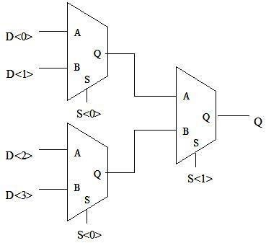

**Fig. 3:** 4-to-1 multiplexer using 2-to-1 multiplexers.

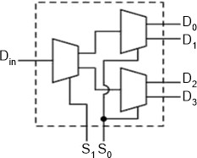

**Fig. 4:** 1-to-4 de-multiplexer using 1-to-2 demultiplexers.

# Part II: Encoder and Decoder:

An encoder is a device or a circuit that converts information from one format or code to another. A decoder does the reverse operation of the encoder. It undoes the encoding so that the original information can be retrieved. Both the encoder and decoder are combinational circuits.

Encoding and decoding are very widely used ideas. They have applications in electronic circuits, software programs, medical devices, telecommunication and many others. In this experiment, a very basic 2-to-4 line decoder and a decimal to BCD encoder will be constructed.

A decoder can convert binary information from n input lines to a maximum of 2*n* unique output lines. The 2-to-4 line decoder will take inputs from two lines and convert them to 4 lines.

A B

D0

D1

D2

D3

**Fig. 5:** 2-to-4 line decoder

The expressions for implementing 2-to-4 line decoder are

|  |  |
| --- | --- |
| 𝐷0 = 𝐴̅𝐵̅ | (6) |
| 𝐷1 = 𝐴̅𝐵 | (7) |
| 𝐷2 = 𝐴𝐵̅ | (8) |
| 𝐷3 = 𝐴𝐵 | (9) |

Truth table for 2-to-4 line decoder is given below –

|  |  |  |  |  |  |
| --- | --- | --- | --- | --- | --- |
| A | B | D0 | D1 | D2 | D3 |
| 0 | 0 | 1 | 0 | 0 | 0 |
| 0 | 1 | 0 | 1 | 0 | 0 |
| 1 | 0 | 0 | 0 | 1 | 0 |
| 1 | 1 | 0 | 0 | 0 | 1 |

A decimal to BCD encoder converts a decimal number into Binary Coded Decimal (BCD). The expressions for implementing the decimal to BCD encoder –

Y0 = D1 + D3 + D5 + D7 + D9 Y1 = D2 + D3 + D6 + D7 Y2 = D4 + D5 + D6 + D7

Y3 = D8 + D9

Truth table for decimal to BCD encoder is given below –

|  |  |  |  |  |
| --- | --- | --- | --- | --- |
| **Dec.** | **Y3** | **Y2** | **Y1** | **Y0** |
| D0 | 0 | 0 | 0 | 0 |
| D1 | 0 | 0 | 0 | 1 |
| D2 | 0 | 0 | 1 | 0 |
| D3 | 0 | 0 | 1 | 1 |
| D4 | 0 | 1 | 0 | 0 |

|  |  |  |  |  |
| --- | --- | --- | --- | --- |
| **Dec.** | **Y3** | **Y2** | **Y1** | **Y0** |
| D5 | 0 | 1 | 0 | 1 |
| D6 | 0 | 1 | 1 | 0 |
| D7 | 0 | 1 | 1 | 1 |
| D8 | 1 | 0 | 0 | 0 |
| D9 | 1 | 0 | 0 | 1 |

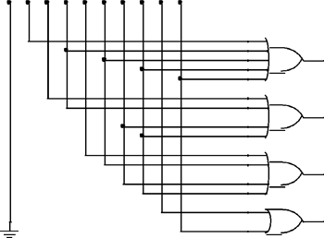D0 D1 D2 D3 D4 D5 D6 D7 D8 D9

Y0

Y1

Y2

Y3

**Fig. 6:** Decimal to BCD encoder

# Priority encoder:

A priority encoder is a [circuit](http://en.wikipedia.org/wiki/Electronic_circuit) or [algorithm](http://en.wikipedia.org/wiki/Algorithm) that compresses multiple [binary](http://en.wikipedia.org/wiki/Binary_code) inputs into a smaller number of outputs. The output of a priority encoder is the binary representation of the original number starting from zero of the most significant input bit. They are often used to control [interrupt requests](http://en.wikipedia.org/wiki/Interrupt_request) by acting on the highest priority request. If two or more inputs are given at the same time, the input having the highest priority will take [precedence.](http://en.wiktionary.org/wiki/precedence)

In this experiment a 4-to 2 priority encoder with a priority sequence of 2,1,3,0 has been shown. It means, in this priority encoder 2 has the highest priority and 0 has the lowest. If 2 is high then other numbers are ignored (even if any of them are high at the same time) and output would be binary representation of 2, i.e., Y1Y0=10. If 2 is found to be low, then next priority is given to 1. So, in this case if 1 is high, then 3 and 0 are ignored and output will be binary representation of 1, i.e., Y1Y0=01 and so on.

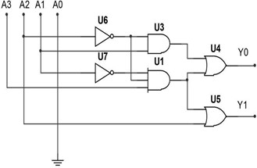

**Fig. 7:** 4-to 2 priority encoder with a priority sequence of 2,1,3,0

The expressions for implementing the above priority encoder–

Y0 = A2’.A1 + A3.A2’.A1’ Y1 = A2 + A3.A2’.A1’

Truth table for this priority encoder is given below –

|  |  |  |  |  |  |
| --- | --- | --- | --- | --- | --- |
| A3 | A2 | A1 | A0 | Y1 | Y0 |
| x | 1 | x | x | 1 | 0 |
| x | 0 | 1 | x | 0 | 1 |
| 1 | 0 | 0 | x | 1 | 1 |
| 0 | 0 | 0 | 1 | 0 | 0 |

# Pre-Lab Homework:

Read about the characteristics of encoder and decoder circuits from any book or websites and use PSIM to generate the output of the circuits provided in this lab sheet. Save the simulation results and bring it to the lab.

|  |  |  |  |
| --- | --- | --- | --- |
| **Apparatus:** | | | |
| 1. | NOT Gate - | IC 7404 | 1 [pc] |
| 2. | AND Gate - | IC 7408 | 1 [pc] |
| 3. | OR Gate - | 5 input OR | 1 [pc] |
|  |  | 4 input OR | 2 [pcs] |
|  |  | 2 input OR | 1 [pc] |

# Precautions:

1. Make sure that all the LEDs and the toggle switches of the trainer board are working properly.
2. Do not short any connections. Short connection can produce heat (due to high current flow) which is harmful for the components.

# Experimental Procedure:

1. Connect the circuit according to the figures.
2. Use the toggle switches on the trainer board for providing input signal to the circuits. Connect the outputs to the LEDs on the trainer board.
3. Apply the input signals and observe and note the corresponding output signals.

# Simulation and Measurement:

Compare the simulation results with your experimental data and comment on the differences (if any).

# Results/ Findings:

Students will implement the circuit in the Trainer Board and match the theoretically obtained truth table by matching outputs for individual input configurations. If the practically obtained truth table does not match they will also investigate the errors.

# References:

1. Thomas L. Floyd, “Digital Fundamentals” 9th edition, Prentice Hall.
2. M. Morris Mano, “Digital Logic & Computer Design” Prentice Hall.